**3.Git-HOL  
  
Branching**1.Create a new branch “GitNewBranch”

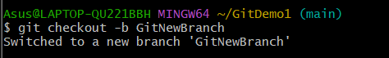

2. List all the local and remote branches available in the current trunk. Observe the “*” mark which denote the current pointing branch.

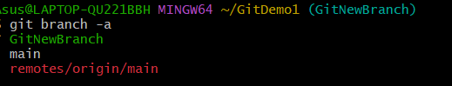

3. Commit the changes to the branch.

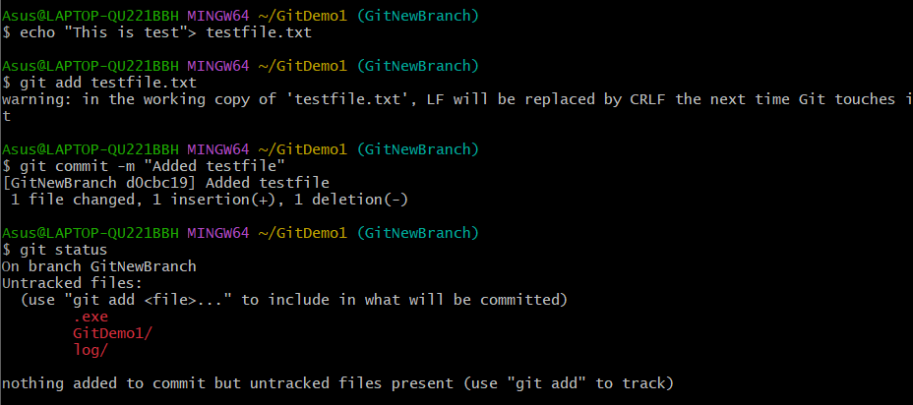

5. Check the status with “git status” command.

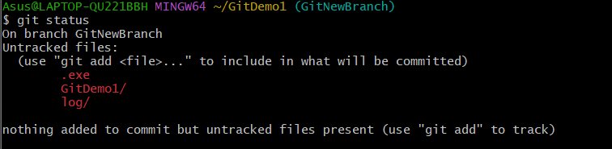

**Merging**

1. Switch to the master

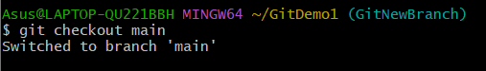

1. List out all the differences between trunk and branch. These provide the differences in command line interface.

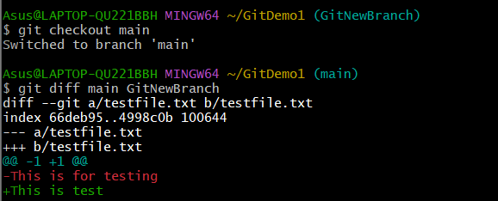g

1. List out all the visual differences between master and branch using P4Merge tool.

**git config --global diff.tool p4merge**

**git config --global difftool.p4merge.cmd '"C:/ProgramFiles/Perforce/p4merge.exe" "$LOCAL" "$REMOTE"'**

1. Merge the source branch to the trunk.

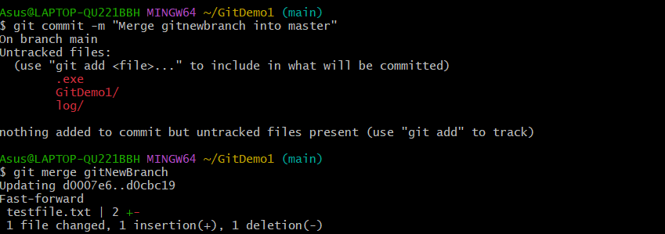

5. Observe the logging after merging using “git log –oneline –graph –decorate”

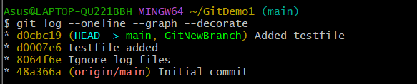

6. Delete the branch after merging with the trunk and observe the git status.

